Provider Certification Archiving Procedure 4-2013

Provider Certification Previous Volumes – Currently Certified ARCHIVE Data Entry Process

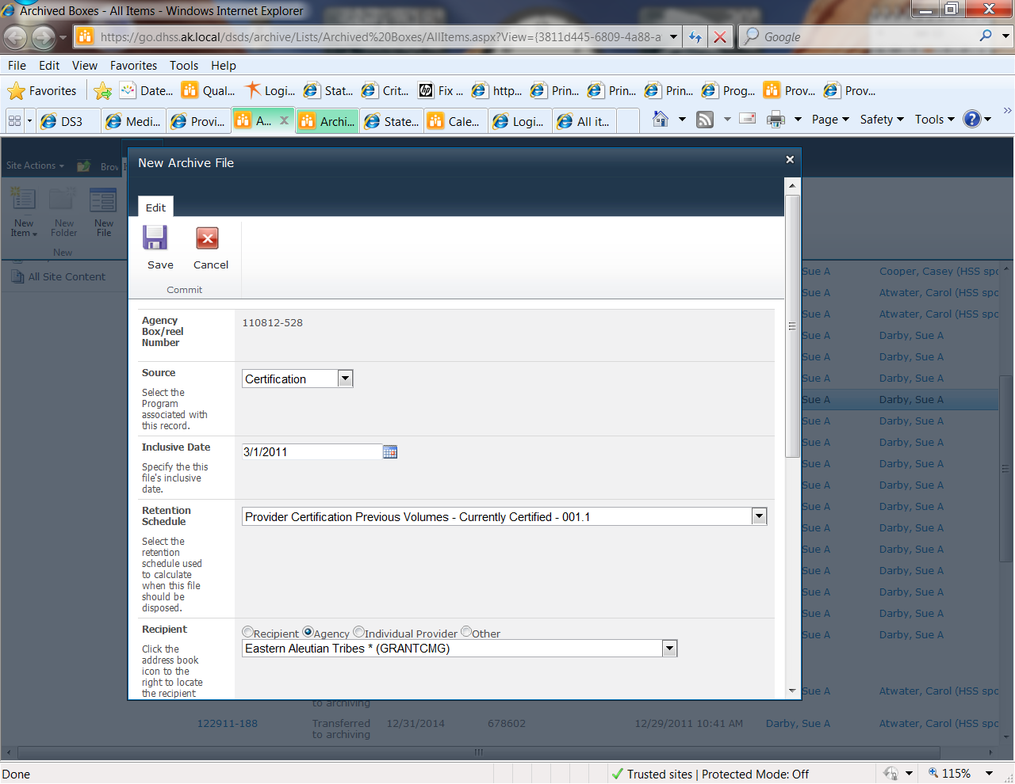

Agency Box is Automatically Assigned

Source is always Certification for QA files

Inclusive date is the previous cycles END Date

This is only for the OPEN providers to get extra hardcopy materials stored off site.

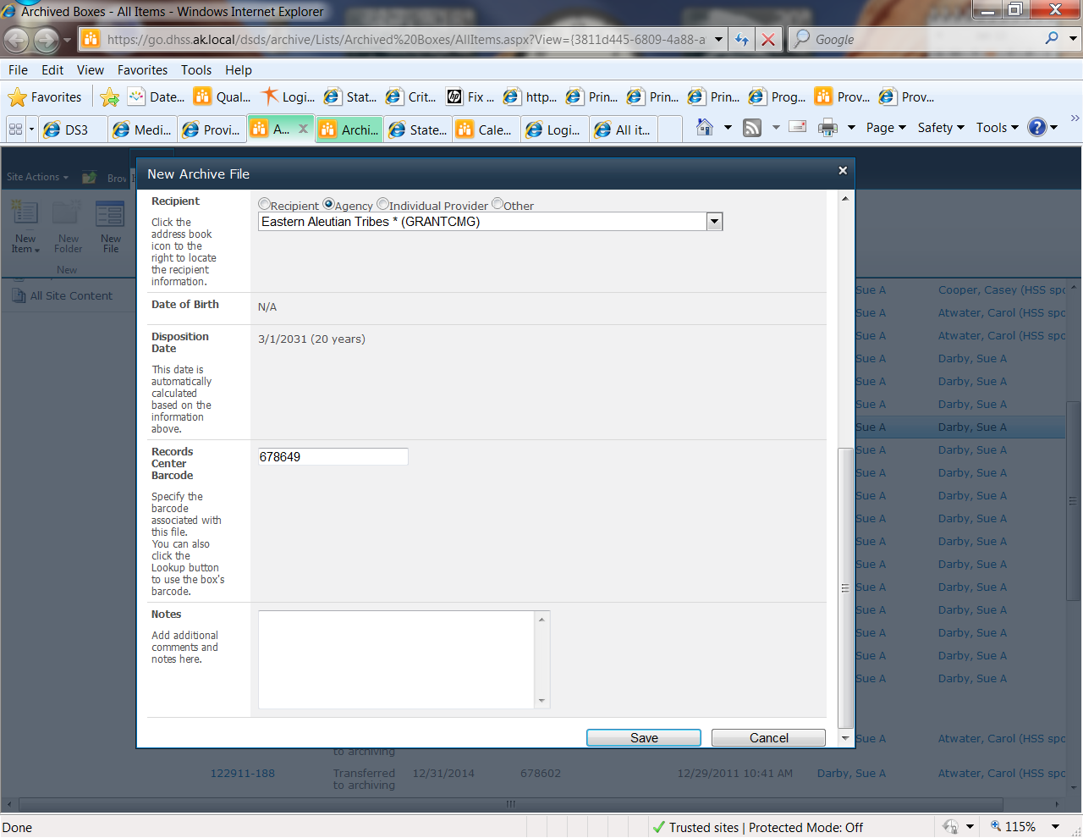

Choose a provider Agency

Be sure the provider numbers match!

Describes the contents of the file. I.E. Certification Materials for 2011-2013 Certification Cycle

Auto Filled based on the box chosen

Automatically calculated based on the Inclusive date (Certification Cycle End Date)

Hint: To make entering notes in DS3 more efficient for multiple entries per provider finish entering the box then download a report to Excel, filter to only show the box that was just finished, alphabetize and enter 1 note in DS3 for each provider noting the number of folders contained in the box and the contents from the Excel Report.

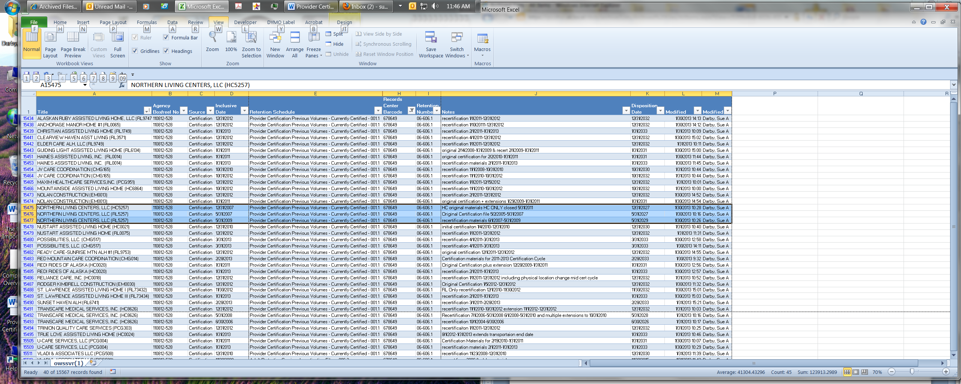

DS3 NOTES

Provider Record Location Note should have:

Agency Name:

Agency Box No:

Records Center Barcode:

Notes:

|  |  |  |  |
| --- | --- | --- | --- |
| **Title** | **Agency Box/reel No** | **Records Center Barcode** | **Notes** |
| ALASKAN RUBY ASSISTED LIVING HOME, LLC (RL9747) | 110812-528 | 678649 | recertification 1/1/2011-12/31/2012 |

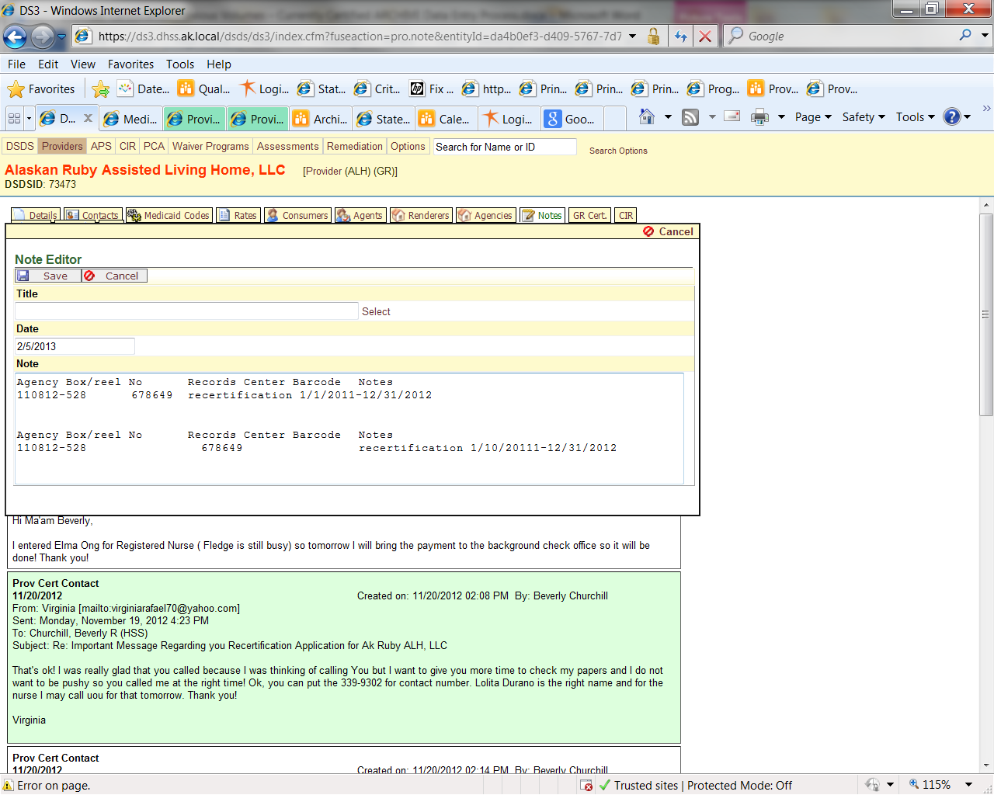

Use the spacebar to fix the alignment

Add additional folder entries to the same note

Final note should be number of folders in box

How it Copy/Pastes from Excel

Transferring to Archives

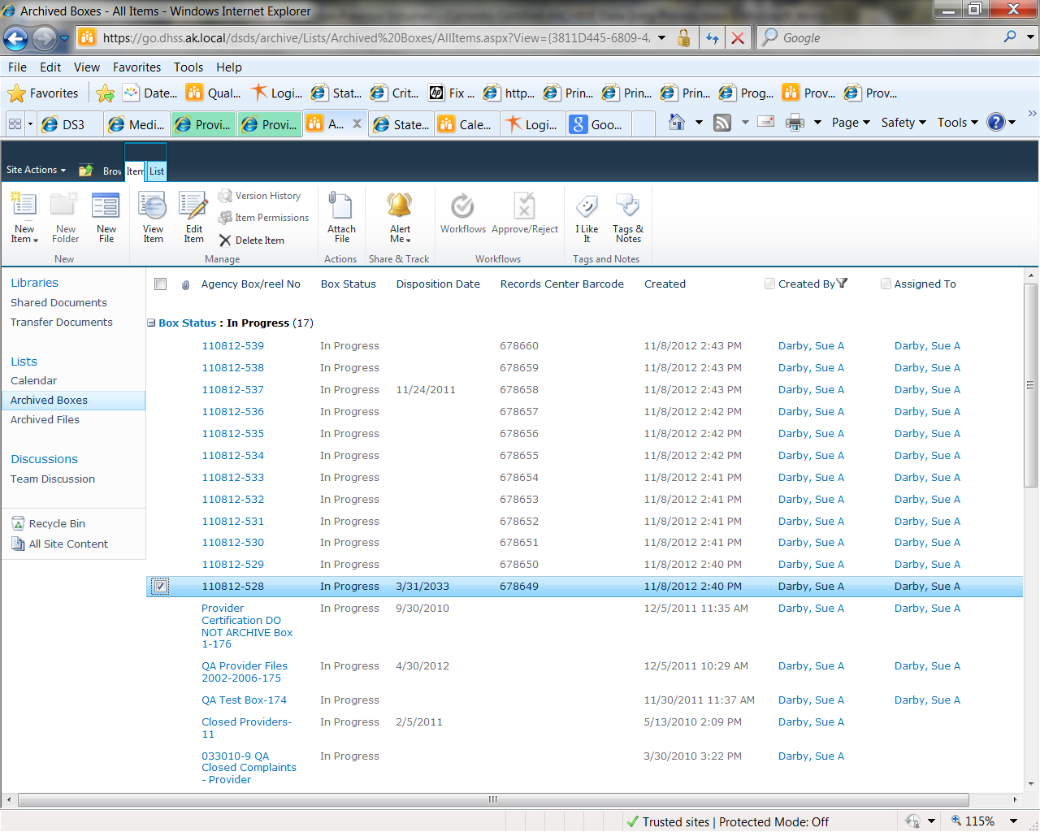

Choose a box to transfer

Go to Edit Item

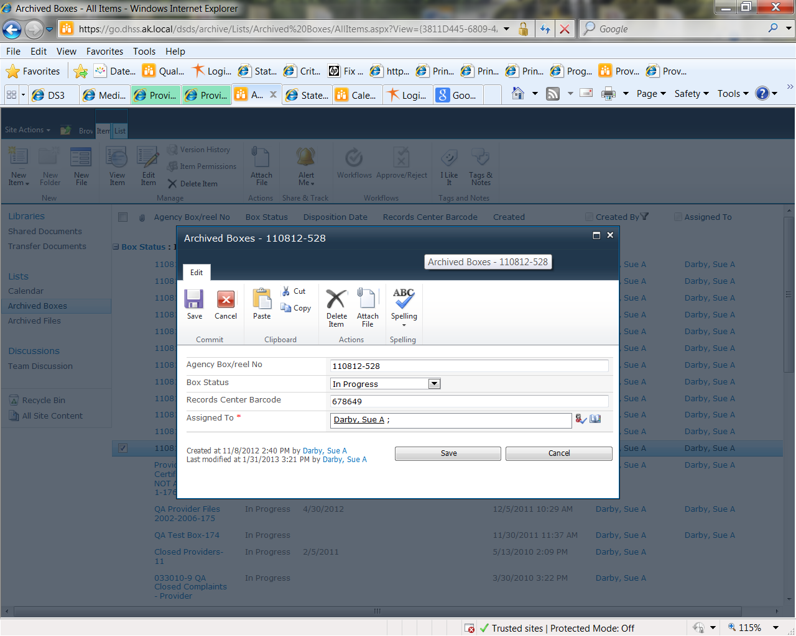

Change the box Status to “Ready to Be Archived”

Assign it to YOURSELF or you will not be able to generate the Report needed for Transfer!

Got to List Tools > List > Generate Report > Open

This is the RTL that must be sent to Admin for further processing. Admin will notify Clerk of any changes to be made and then arrange for pick up.

**Preparing boxes for pick up**

Ensure all boxes listed on RTL are in the stack for pick up. Barcodes should be in right hand corner of the box with 2x4 address label with the Box Number just below. Files should all face up and the same direction. Each box should have a lid. ONLY use Banker’s boxes.

**NOTE:** The same processes can be used for other types of files to be sent for archive i.e. closed – voluntary, closed involuntary, auxiliary files etc. The *Source* is ALWAYS *Certification* and ALWAYS requires an *Inclusive Date. QA Source* files may include other types of reviews or investigations but would also be the same procedure.